IKG Context Pack Explained
Oct 23, 2026 · @Pratik

What the context pack is
The IKG context pack is one zip (ikg_pack.zip, rebuilt every weekday at 19:00 ET) that gives Agile Dev Assist everything it needs to plan, write, check and review a change to the IKG repository without re-reading git or Greenplum at run time. It is built by the Knowledge Pack builder from four sources: the ikg-dags repository, the Greenplum catalog, the skills/ikg/ folder and the gp/ikg/gp.md table list.
Inside the zip the sources become facts (facts/structure.json, facts/tables.json), a knowledge layer (conventions, checkable rules, glossary in derived/derived.json), prompt-ready cards, a search index (BM25 + vectors) and a copy of the repository.
How Agile Dev Assist consumes it. A story runs through seven agents in order; with a pack attached three of them (knowledge, data, safety net) need no model call at all.
Step | Agent | Model | What it does with the pack
1 | Story agent | gpt-4o-mini | Resolves business words to tables and keys using the glossary; lists tables_mentioned
2 | Knowledge agent | none | Selects the conventions, rules and definitions relevant to this story (structural rules always)
3 | Data agent | none | Hands over columns, types, keys, sample rows and lineage of the mentioned tables
4 | Repo agent | gpt-4o-mini, 3 steps | Registration points and companion files come pre-computed; it only reads the sibling and exemplar files
5 | Planner | gpt-5 | Builds the file list; proven pack rules complete it by code (history sibling, registry entries)
6 | Safety net | none | Adds any registry or companion the plan still misses, from proven rules only
7 | Coder | gpt-5, one file at a time | Copies the folder skeleton and exemplar; the validator runs after every file and sends findings back for a fix round
8 | Validator | none | Syntax, SQL parse, Airflow DAG checks and every regex rule from the yaml files
9 | Reviewer | gpt-5 | Judges the delivered set against the recipe, the conventions and the findings
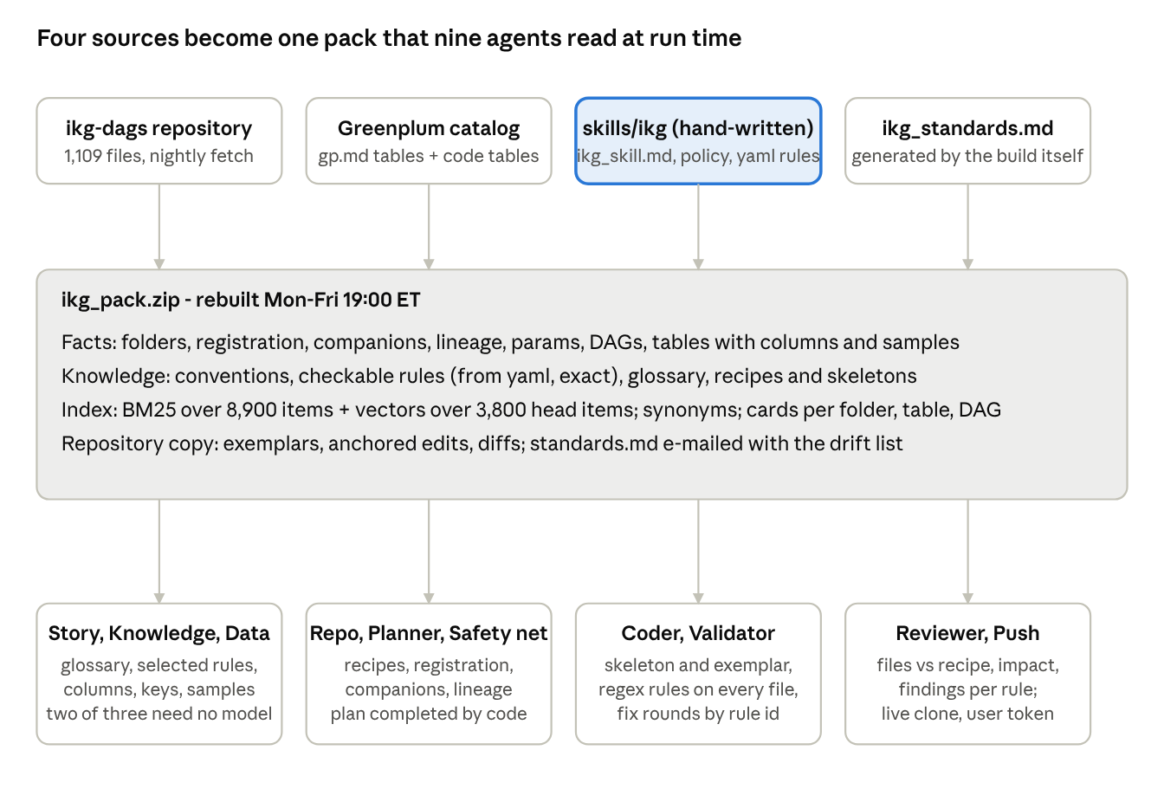
context pack · 4 sources, 4 layers, 9 agents
The hand-written folder (accented) is the only source a person maintains; the other three are read or generated by the nightly build.

The inputs, one by one
Eight inputs feed the pack. Three are hand-written and change rarely (ikg_skill.md, the policy file, the yaml rules); the rest are regenerated from the repository and the database every night.

1. ikg_standards.md - generated repository facts
Written by the builder at the start of every build into skills/ikg/, then read by the same build. It never needs editing; it changes only when the repository changes.
Contains: folder map (97 folders) with purpose, typical file and how a new file is registered; companion rules (ikg_create_profiles ↔ ikg_create_profiles_history, name rule drop curr, 45/46 pairs); per-folder naming (47/47 DAG files start with ikg_); parameters with usage counts and meaning; per-folder recipes (numbered steps, the registration example line, the skeleton of the typical file); DAG map (ikg_data_refresh.py, 400 tasks, one task group per SQL folder); validation folders.
Agent | Use
Repo agent | Registration points and companions come from here instead of scanning 1,109 files - the repo stage dropped from minutes to seconds
Planner | Starts from the folder recipe: primary file, history sibling, entry in ikg_data_refresh.py, TABLE_CONFIG entry; proven rules are added to the plan by code
Coder | Copies the skeleton (DROP / CREATE / DISTRIBUTED BY / ALTER OWNER / GRANT with params) and inserts the registration line exactly as the example shows
Reviewer | Checks the delivered files against the recipe: missing sibling, missing registration, wrong folder

2. ikg_skill.md - hand-written domain knowledge and conventions
The merge of the team's nine markdown files: code conventions, business definitions, household domain, advisor hierarchy, FA/TA entitlement model, metadata writing standards.
Agent | Use
Story agent | "statement household" → acc_mhh_n, "entitled FA" → si_pilot_fa_shp_map with has_all_accounts = 1; the right tables_mentioned
Knowledge agent | Selects ~25 relevant conventions per story; structural ones ("every new profile table needs a history script") are always kept
Planner | The 5-step "adding a column to a profile table"; "never read a *_profile_curr_ikg inside a script - trace to the intermediate table"
Coder | SQL file pattern, column naming (mhh_, _cnt, _4w, has_ flags), parameter names, metadata names for comments
Reviewer | Rule of thumb (logic in intermediate tables), validation checklist (row counts vs previous profile date, null share, key uniqueness)
The validator uses it only indirectly: the nightly model layer turns sentences such as "never the literal schema core_wma_shared" into regex rules where it can.

3. standards_config.yaml - STD-VAR / STD-NAME / STD-PAT rules
Regex rules with id, pattern, severity, message and examples: schema as variable, no hard-coded dates, no SELECT * in INSERT, no natural joins, INSERT with column names, JOIN needs a condition. Read exactly by the builder, no model involved.
Agent | Use
Validator | Primary consumer: every rule runs on every generated file; a hit is a finding with rule id, severity, message. Critical and high findings send the file back to the coder
Coder | Receives the active rules as must / must-not before writing, and example_correct when fixing a finding
Reviewer | Sees findings per rule id in standards_check; does not re-judge what the regex settled
Rules with check_type (output_count, name_matching, drop_create_consistency, alter_grant_matching) are skipped today; they need code, not a regex, and can be added as validator checks on request.

4. ikg_project_rules.yaml - IKG-specific rules
Same mechanism as 3 (IKG-GRANT-001 owner and grant via params, and so on). IKG-only rules live here; generic SQL rules in 3.

5. severity_mapping.yaml - what blocks
Rule id → critical / high / medium / low, blocking flags, escalation, build gates. The severity override is applied to every rule from the other yaml files, so this file decides what blocks a fix round. Build gates (max_allowed_issues, min_quality_score) are not wired yet; the engine's own threshold applies.

6. sql_rules_greenplum.yaml - the trimmed Greenplum rules
18 regex rules replacing the generic multi-database sql_rules.yaml: DISTRIBUTED BY required, RANDOMLY and date keys flagged, CROSS JOIN, JOIN without ON, DELETE / UPDATE without WHERE, function around profile_date, ORDER BY in CTAS, literal schemas, hard-coded dates, DROP IF EXISTS and OWNER / GRANT required, TEMP tables, pandas full-table reads. Validation and history folders are exempt by path. Consumed like 3.

7. gp.md - the 9 always-described tables (plus up to 400 found in the code)
For each table the builder stores, from Greenplum at build time: columns with types, nullability and comments, keys, distribution key, row estimate, 3 sample rows, a model-written description, and lineage (which scripts write and read it). Tables in core_nlg and sandbox_prj_smart_insights are excluded for IKG.
Agent | Use
Data agent | No live query at run time; hands the planner the real columns, keys, distribution key and sample values of the mentioned tables
Planner | Which columns exist, the join keys (acc_mhh_n, ip_cli_i, acc_i), where a column is produced (lineage); read_by lists the consumers a change impacts
Coder | Exact column names and types - no invented columns, correct casts, right DISTRIBUTED BY
Validator | sqlglot parse plus the rules; known tables and columns are cross-checked
Reviewer | Flags columns the pack does not know and lineage impact not addressed

8. The repository - raw/repo in the pack, 1,109 files
Agent | Use
Repo agent | Indexed once (identifier index, cached): search_repo, read_file, grep answer in milliseconds; one exemplar per folder
Planner | Reads the sibling and the registration file it will modify; lineage graph for impact
Coder | Reads exemplar and target files in full; edits are anchored to verbatim lines (find / replace)
Validator | Airflow DAG checks on the real DAG file; modified files diffed against the original
Reviewer | Before / after of modified files; consumers (read_by) unaffected
Push | Not from the pack: a live clone on ikg-master, branch {story}-ikg-{feature}, merge request to ikg-dev with the user's own token

What is embedded
Everything in the pack is searchable two ways: a keyword index (BM25) over every item, and a vector index (embeddings) over the items that carry meaning. The two are fused at query time, so an agent asking "how is a new profile table registered" lands on the right recipe whether it uses the team's words or not.
Items. The builder turns the pack into about 8,900 knowledge items (items.jsonl), each a short text with a title and a context header:
Kind | Count (IKG) | What one item holds
chunk | 6,090 | A slice of a code file with a header: system, path, folder purpose, registration rule, tables it builds
table | 1,556 | A table's description, columns, keys, distribution, writers and readers
file | 994 | A file's summary, language, folder, tables touched
folder | 106 | Folder purpose, typical file, naming, registration
param | 56 | A {{params.X}} with its meaning and example files
dag | 53 | A DAG, its task groups, folders and task order
companion | 8 | A companion rule with its example pair
skills sections | per heading | Each section of ikg_skill.md, ikg_standards.md, the policy file and the yaml files
What gets a vector. Embedding every chunk cost 2.3 million tokens per build and caused the 429 throttling. The pack now embeds dense_items: head: every table, folder, DAG, parameter, companion and skills section, plus the first chunk of each code file (the one carrying the context header) - about 3,800 items and 0.33 million tokens. The remaining code chunks stay in BM25 only, which is the better index for identifiers and SQL anyway.
Setting | Value | Effect
Model | embedder (text-embedding-3-small, 512 dimensions) | Same Azure resource as the chat models
Text per item | first 1,200 characters | Title + context header + the start of the content
Pacing | 300,000 tokens / minute, 4 parallel requests | Under the 350k quota of the deployment; no 429 loop
Cache | by text hash, shared across builds | Only changed items are embedded on later builds; a rebuild of an unchanged repository embeds nothing
Time cap | 8 minutes per pack | Whatever is left is BM25-only this build and embedded next time
Retrieval at run time. A query is expanded with the pack's synonyms (shh → statement household, hist → history), run against BM25 (top 40) and against the vectors (top 40), and the two lists are merged by reciprocal rank. Results carry the item kind and path, so the agent can open the card or the file. Queries themselves are embedded with the same model and cached, so a repeated question costs nothing.
Not embedded. Secrets never enter the pack. Sample rows are limited to 3 per table and only for the described tables. Tables in core_nlg and sandbox_prj_smart_insights are excluded for IKG; folders such as logs, archive, deprecated, node_modules are excluded from every pack.

What each agent would miss without each input
Missing input | Symptom
ikg_standards.md | Planner guesses registration and companions: over-plans (18 files), re-plans, budget spent before coding
ikg_skill.md | Wrong business keys (marketing vs statement household), logic put in the profile script, no validation artifact
yaml rules | Bad SQL reaches the reviewer and the developer; fix rounds become opinion instead of a rule id
gp.md and the described tables | Invented columns, wrong types, wrong distribution key, no impact list
repository copy | No exemplar to copy, edits cannot be anchored to real lines, nothing to diff
What stays hand-written. Three things no generator can produce: the business meaning of terms (ikg_skill.md), the team's decisions about what is mandatory, frozen or reviewed (ikg_policy.md, optional, from the standards-template questions), and the rule catalogue (yaml). Together they are a few hundred lines and change a few times a year.
How the pack stays current. The DAG knowledge_pack_daily runs Monday to Friday at 19:00 ET and rebuilds the three packs (IKG, ODM, NLG) from scratch; unchanged items are served from cache, so a quiet day costs cents. Each run regenerates ikg_standards.md, e-mails pack.md, manifest.json, health.json and standards.md (facts, policy and a "changed since the previous build" list of new folders, registration points, companion rules, DAGs and parameters) to the DL, and replaces output/ikg/ikg_pack.zip only when the build is healthy. Agile Dev Assist picks the pack up through the prebuilt IKG template, so every user works from the previous night's repository.

